Instructions for Accessing Input Feeder Data

4/8/2025

1. Connect to UVM VPN (sslvpn2.uvm.edu). Instructions available here: <https://www.uvm.edu/it/kb/article/sslvpn2/>

1. Identify files you want to retrieve from the server and corresponding path:
   1. Open a new Terminal.
   2. Enter the command ssh [username@nest-vt.uvm.edu](mailto:username@nest-vt.uvm.edu), replacing username with your UVM NetID.

* 1. Enter your NetID password (note that the password will not appear when typing), and complete Duo two-factor authentication. If login is successful, you should see the prompt [username@nest-vt ~]$.

* 1. Change to the /nest-vt-fs1 folder in /netfiles using the command cd /netfiles/nest-vt-fs1.
  2. You can now use the ls and cd commands to navigate to the files you want to download. For example, the VEC feeder data for this demo are located in the data_for_MAPLE_BST_Demo folder. Take note of the file path.

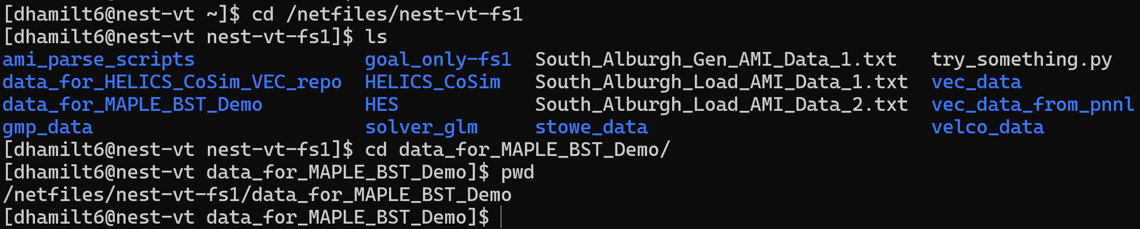

1. Transfer the desired files from the UVM server to your local machine:
   1. Open a new Terminal.
   2. Enter the command scp -r username@nest-vt.uvm.edu:/path/to/file /path/to/local/folder, where username is your UVM NetID, /path/to/file is the path to the file you want to transfer on the server, and /path/to/local/folder is the path to the folder you would like to copy the file to on your local machine. Note there should be a space between the file paths.
   3. Enter your NetID password and complete Duo two-factor authentication. Your file transfer should begin.

